The Economic Impact of Gaelic Arts and Culture within Glasgow
Dr Douglas Chalmers, Division of Cultural Business, Glasgow Caledonian University
Professor Mike Danson, Paisley Business School, Paisley University
Introduction
Over the last 20 years, increasing acknowledgement has been made of the economic impact of arts and cultural activities, and their role in providing a series of local benefits in addition to creating a richer artistic and cultural environment. A range of studies (Myerscough, 1988, 1995; Hughes, 1989; MacKay Consultants and McGrath, 1991; Sproull and Ashcroft, 1993; Matarasso, 1996; EKOS, 2000; HIE, 2001; Chalmers, 2003; Dunlop et al., 2004) have sought to investigate such impacts in a diverse range of urban and rural settings, from the Western Isles to Glasgow and other conurbations, either independently, or as part of the ‘creative industries’.
This increasing interest has been brought about partly through the shift in most industrialised regions from manufacturing to services, with the ‘labour intensive’ nature of much of the Arts, coupled with high local sourcing, raising the possibility of cultural industries acting in part, as a replacement for declining manufacturing employment.
Against this background, the question of cultural tourism and niche marketing of cultural aspects of the local economy have also been raised as important issues in an increasingly competitive globalised economy.
Resulting from this has been a growing interest in the role of Arts and Culture in its ‘traditional sense’. Importantly however, there has also been increasing interest in the whole question of language, culture and diversity as a motor for economic change through its impact on ‘human capital’ This links to a growing prominence given to the importance of ‘intangibles’ in economic development by local development agencies. In practical terms, one of the consequences of this approach has been an attempt to explore the relationship between social attributes – such as diversity – and how this may give comparative advantage in aiding innovation and local development through the mobilisation and organisation of resources, (particularly human resources). In this context diversity can be understood in its widest sense – including aspects of cultural and linguistic difference, such as that offered by Gaelic and other languages.
Informed by this approach it is timely, therefore, that Glasgow examines the economic impact which can be ascribed to Gaelic provision, and in particular to Gaelic arts and cultural provision.
Towards an estimation of the impact of Gaelic arts and culture in Glasgow
Following previously established and generally accepted research )Sproull and Ashcroft, 1993) a useful definition of the Gaelic artistic and cultural ‘industry’ would be to view it as comprising the providers of Gaelic artistic and cultural goods and services and those who consume them. The consumers of such goods and services would comprise not only fluent Gaelic speakers but all with a professional or personal interest in the language and its associated culture (including tourists). The providers would encompass a wide range of services and organisations, such as those mentioned elsewhere in this overall document and would certainly include, local Feisean, Gaelic Book providers, those who stage and take part in musical or cultural evenings, those employed by the media in producing arts and cultural programmes related to or in the medium of Gaelic etc. A useful working definition of the Gaelic artistic and cultural sub-sector in Glasgow might thus be:
“all those activities and jobs, whose principle purpose is the provision of Gaelic related artistic and cultural related goods and services”
The economic impact of this sector goes beyond those individually employed in this area, for several reasons. Firstly the income earned by those directly employed will be further spent, either for personal consumption (the multiplier effect), or to purchase further inputs for their activity (the linkage effect). This will create a multiplied effect in both cases, with the local economic impact greater than the original income. In addition, extra spend by audiences can also in some instances be substantial.
Also, and importantly, it can be also expected that a whole range of further dynamic effects may be created by the provision of such artistic and cultural output. Recent studies (Chalmers, 2003; Chalmers and Danson, 2004a and b) have outlined the perceived positive impact on a range of variables all of which can be shown to have a longer term impact on the local economy, such as tourism; attachment to community and community confidence; decreasing rates of out-migration and increasing rates of in-migration. Although more specifically mapped within rural areas, these can also be expected to exist in every community with a thriving cultural sector. Having acknowledged this, capturing the overall effects of this are more difficult than capturing some of the more ‘concrete’ data associated with jobs and spending, and may also exhibit a long term effect rather than an immediate impact.
An immediate aim of measuring the size of the Gaelic arts and cultural sub-section of the Glasgow economy (within a broader measurement of those providing Gaelic services in general) however, would involve a less difficult task and would involve focusing on the providers of Gaelic artistic and cultural services, and essentially the jobs and activities specifically associated with this. This is not necessarily without its complications however, as it involves estimating the contribution made by such activities to the local economy over and above would have occurred in the absence of Gaelic artistic and cultural activity. In other words, if one were to calculate the impact of Gaelic musical evenings, which if they disappeared would simply be replaced by similar (but non-Gaelic) musical evenings, then the Gaelic activity has not in fact been ‘additional’ to what would have taken place in its absence. Despite these caveats however, and the acknowledged difficulties associated with measuring the economic impact of cultural activities, a growing body of expertise can be drawn upon in making such an estimate.
Practicalities of such a study
Moving from the abstract definition of the artistic and cultural sector given above, several working approaches exist to capturing the boundaries of such sub-sectoral activity. A recent study of the economic impact of the cultural sector in Scotland (Dunlop et al., 2004) employed (amongst other approaches) the Scottish Arts Council sectoral categorisation: Dance; Music; Visual Arts; Drama; Festivals; Arts Centres; Arts Development and Literature, plus the impact of radio, television and crafts. Related to this approach, earlier studies have evolved a working definition of the Gaelic artistic and cultural sub sector of the economy (Bryden and MacKinnon, 1993), much of which covers a similar area. This paper introduces a study with the overall aim of mapping the direct economic impact of all those involved in Gaelic service provision. To achieve this, several stages were undertaken and are reported here. First, the research was put into the context of the recent and rapidly changed social and economic environment of the Glasgow metropolitan area. Second, estimates of the number of Gaelic speakers, learners and services available to them were produced. Next discussed is the methodology for the survey of the work of Gaelic organisations based in Glasgow, including provision from education and Glasgow-based media organisations such as the BBC. The results are then explored, before discussion and speculation on future developments and competition from other cultural communities conclude the paper.
Background [to follow from DC with few paras from MD on Glasgow economy]
Methodology
Following the initial review of the evolving literature in arts and cultural impacts, the census and other data regarding the current situation of Gaelic speakers and learners within the Glasgow market area were reviewed, as discussed above. This was undertaken in consultation with the agency dedicated to pro-active market research in the sector within the city: Glasgow Grows Audiences (GGA), to maximise effectiveness and to minimise duplication. The background environmental and population analyses provided the foundations for the subsequent survey of all known Gaelic organisations within Glasgow to ascertain the extent of their activities, expenditures and employment numbers associated with Gaelic, including the cultural and artistic aspects of their activities. To inform this survey, a review of secondary research upon the impacts of arts in Glasgow was pursued again in close co-operation with GGA and Glasgow Gaelic arts officer. Two surveys were generated and conducted: of the self-employed tutors, teachers, musicians, etc. and those who employed staff at least some of whom were involved in the Gaelic arts and cultural sector. With the contacts in GGA and the City Council, XX individual and YY company surveys were distributed by post in the spring of 2007.
Stage 3 of the approach was to analyse the data from these questionnaires on the direct economic impact to allow a robust estimation of overall economic impact of Gaelic arts and culture within the Glasgow area. This would be followed, using current knowledge and practice, to map the additional possible impacts in terms of further dynamic effects of such output; in particular, the implications of the proposed options for An Lochran cultural centre would be estimated.
Findings from Surveys
This paper reports specifically on the impact of the BBC activities in Glasgow.
The Impact of the BBC
BBC Alba based in the new BBC headquarters in Pacific Quay provides a range of services including its TV broadcasts on BBC2 Alba, (mainly broadcasting Thursday evenings during parts of the year) and through the national radio station Radio nan Gaidheal (mostly produced in Inverness). As an indicator of quality and esteem, in 2007 Radio nan Gàidheal won the award of Station of the Year at the 2007 Celtic Media Festival Awards.
The stated aim of the BBC Gaelic unit is to provide broadcast services for the Gaelic speaking audience in Scotland and the UK (with the digitally led ability to receive services abroad via the internet a spin-off – albeit seen as a very welcome one). Their aims are aligned with the six public purposes of the BBC (see http://www.bbc.co.uk/bbctrust/framework/purpose_remits.html).
They are ‘aware they have a crucial role to play in maintaining the Gaelic language’ with the National Plan for Gaelic stating that the BBC is a key provider and facilitator of several outcomes of the plan i.e. ‘a significant increase in the range and quality of Gaelic-medium teaching materials and associated resources’ and ‘an increase in the application of ICT to support learning and extend access to a wider secondary /Gaelic-medium education curriculum’. BBC Alba has bases in Stornoway, Portree, Inverness, Glasgow, Edinburgh and Oban employing staff as indicated in the table below. Of the 102 staff, approximately 63 are based in Glasgow, almost all full time.
Location and categorisation of staff
 | Full Time | Part Time | Freelance | SMO Students*
Glasgow | 55 | 1 | 7
Inverness | 17 | 0.5 | 6 | 1
Oban | 1
Portree | 2 |  | 1
Edinburgh | 1
Stornoway | 26 | 2 | 3 | 2
Total | 102 | 4 | 17 | 3
* Students on placement from the Sabhal mor Ostaig the Gaelic college on Skye.
Of the 102 staff, it is estimated that 56 (55 percent) are educated to degree level with a further 25 having Highers or Diplomas. Seven are in senior management, 22 are producers and 18 clerical. However, it is not possible to give a geographical breakdown of these categories.
Training
In terms of skills development, almost all are receiving training internally. The shift to Pacific Quay – the new Scottish headquarters in Glasgow, and its digital environment, has included craft skill training for everyone – computer based, practical and financial systems. In addition, Gaelic language and scriptwriting are taught to relevant staff. The BBC operates a formal staff development scheme for employees working in the provision of Gaelic related art and cultural products with the aim of the scheme ‘to create a flexible, multi-skilled workforce’. Turnover in the Gaelic Unit is relatively small – being estimated at perhaps 3-4 staff per year. However, the recent closure by the BBC Trust of the ‘Jam’ education service (following anti-competition complaints from the European Union) led to the need for up to a dozen staff having to be absorbed elsewhere.
Expenditure on Gaelic services
Approximate spend in 2006 was as follows:
TV and on-line £2.1m
Radio nan Gaidheal £3.2m
In addition, Gaelic Media Services contributed approximately £2.7m to the BBC for Dè a nis and TV education programmes, and £80k for Radio nan Gàidheal. Until its demise, BBC Jam included within its budget £0.75m for educationally linked Gaelic provision.
Plans for a Gaelic Digital Service (although the final go-ahead for this is still subject to review by the BBC Trust), will lead to a substantial increase in funding – up to approximately £18.5m from all sources. The digital service will be operated jointly with the Gaelic Media Service. The most recent major increase in investment in BBC Alba was approximately 5 years ago, and allowed Radio nan Gàidheal to increase transmissions in the afternoons and at weekends.
On-line and community presence
In its general approach to Gaelic broadcasting, the BBC argues that the key to their operation is the way it delivers, rather than the content as such. The TV and radio broadcasts mentioned above are supplemented by a comprehensive web presence through the site bbc.co.uk/alba, allowing Gaels world wide access to their language and culture. They have argued in the past that money unlocks the content, but different platforms allows wider access.
In addition, a series of partnerships with up to 20 organisations has ensured a wider involvement with the community in pursuit of what BBC sees as its ‘public purposes’. These partners have included Tobar an Dualchais/Kist o’ Riches – to catalogue, digitise and create on-line access over a period of 5 years to approximately 12,000 hours of mainly Gaelic language audio recordings. With Ceòlas, the week-long summer school held annually in South Uist, which teaches a variety of traditional art forms, dance singing, fiddle pipes, Clarsach etc. to approximately 100 students. With Prioseact nan Eilain, to record and make available to the National Poetry Library all the Scottish Gaelic poems contained in Leabhar Mòr. Most recently the BBC broadcast the groundbreaking Hiort – a European opera based around the story of St Kilda organised by Proiseact nan Eilain.
Changes in population who receive their services
According to the BBC, up to ten years ago, there were more listeners and viewers in the Highlands and Islands than elsewhere in Scotland (see diagrams below).
Now they believe that it is rapidly becoming pan-Scottish, with fluent learners regularly taking part in the programmes. This links in with factors seen to be crucial for BBC Alba’s growth and development. The view of the Gaelic Unit staff is that the last 3-5 years have seen the ‘normalisation’ of Gaelic within the BBC’s portfolio of services. In many ways this could be considered as a huge cultural change – the norm is now collaboration with BBC Scotland/ News/ Sport, something that could not be previously claimed to be the case. Staff report that they believe they are ‘now on everyone’s radar’, perhaps helped by the way they believe they have pioneered ‘360 degree’ working – currently seen as the standard approach to production at Pacific Quay.
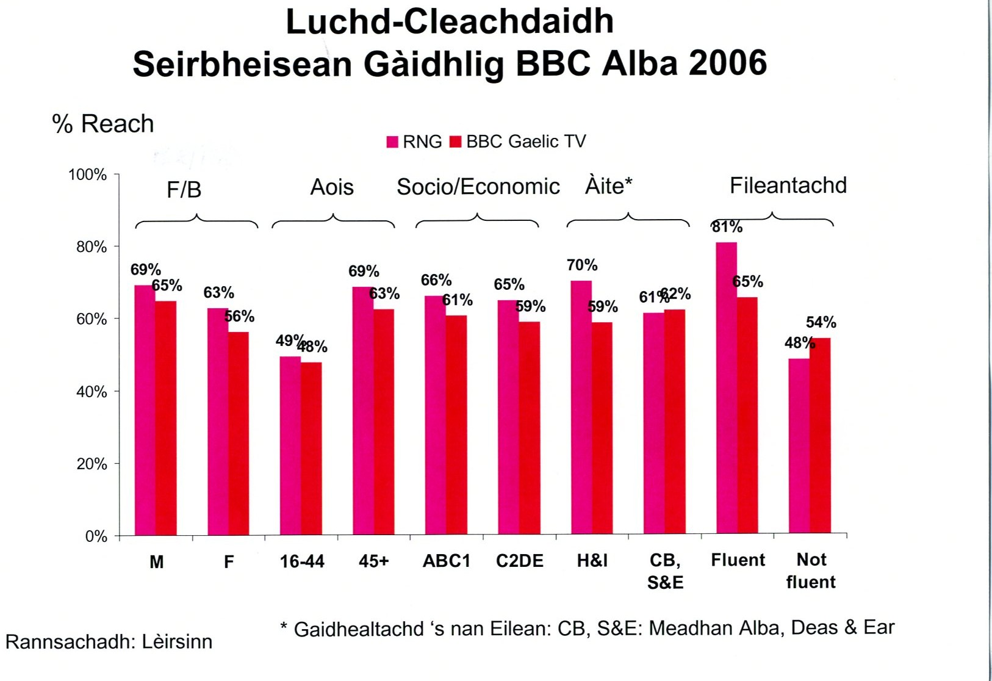

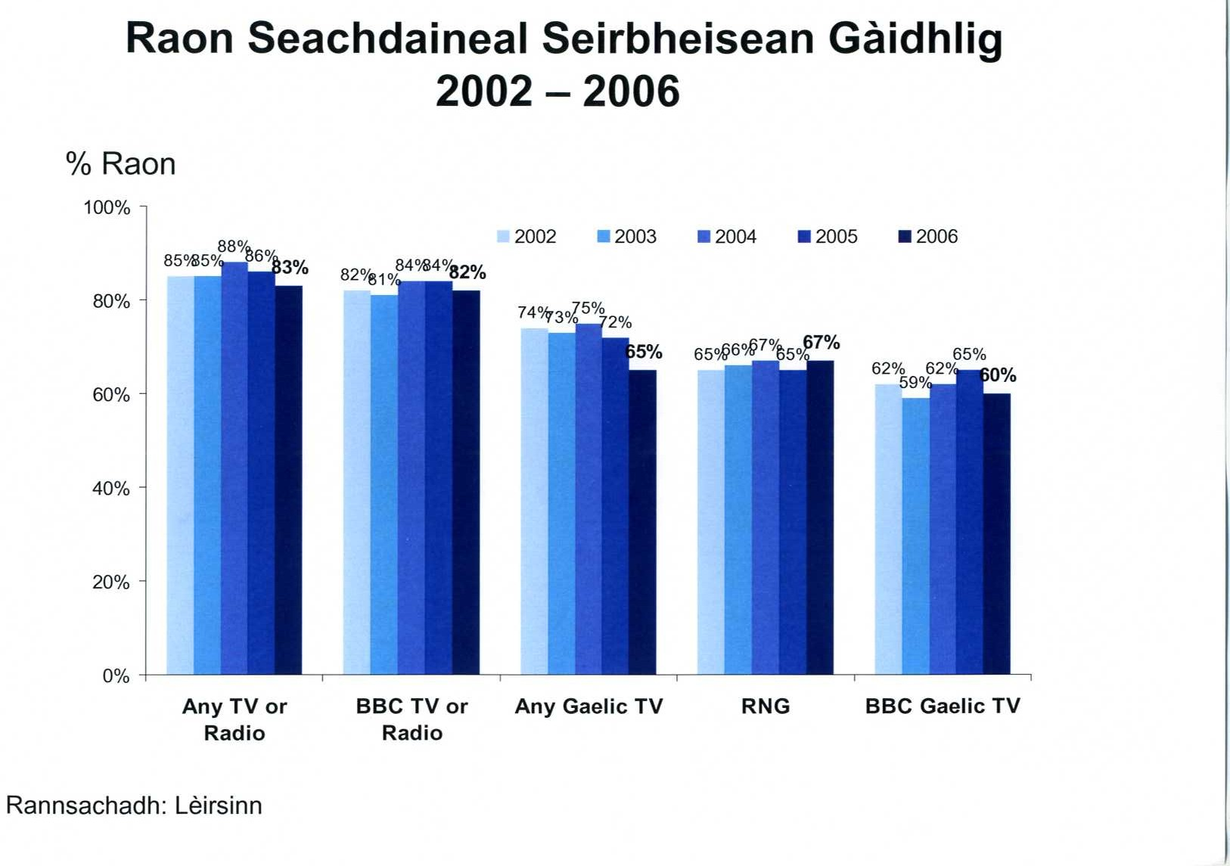

Other factors also seen as notable are the feeling that they ‘have come out of hiding and made what’s done a lot more visible’ They believe there is a lot more embracing of the Gaelic unit by the BBC overall, with a tangible feeling that ‘they’re now part of BBC Scotland’. Several factors were suggested to lie behind this – including the drive for ‘best value’ within the organisation overall. They acknowledge in general greater understanding, and a more sympathetic perspective, plus the impact of programmes such as Eorpa winning awards (BAFTA) and the fact that, via the Gaelic Media Service, they also bring significant money into the BBC.
In terms of the future, the Gaelic Digital Service still faces some uncertainty given the recent cuts announced BBC-wide, while the challenge of digital technology is ironically seen to be less of a problem for the Gaelic unit than might be the case elsewhere, given they had the ‘first integrated media service in the UK – TV/ Radio/On-line’.
With regard to broader external factors, BBC Gaelic staff recognise positive impacts from the establishment of Bòrd na Gàidhlig and from the Scottish Government embracing Gaelic as ‘something that belongs to them’. This is added to by the positive impact from Gaelic Medium Education and arts and cultural groups, like An Lochran and PnE, putting energy into the Gaelic arts. Gaelic music in the 1990s may have been bleak – but now it is incorporated into and integral to the work of the RSAMD (Royal Scottish Academy of Music and Drama). Similarly, they argue that Ur-Sgeul the Gaelic book imprint has also been very important in this acceptance, as has been the work of Clì – the Gaelic learners’ organisation. All these aspects are considered to feed back into the positive upturn for Gaelic at the BBC. Overall, they believe there have been minimal external negative factors, but they acknowledge ‘it is difficult to know how Gaelic broadcasting would survive without the Public Service Broadcasting remit of the BBC’.
Conclusions
References:
Bryden, J. and N. MacKinnon (1993). Gaelic Arts towards a new century, Scottish Arts Council.
Chalmers, D. (2003). The Economic Impact of Gaelic Arts and Culture. Division of Economics and Enterprise. Glasgow, Glasgow Caledonian University.
Chalmers, D. and M. Danson (2004a). Language and Economic Development - Complementary or Antagonistic? Rannsachadh na Gàidhlig 2004, Edinburgh.
Chalmers, D. and M. Danson (2004b). Sustainable Development: Building Social Capital in Gaelic language Communities. Scottish Economists Conference, Perth.
Dunlop, S., S. Galloway, et al. (2004). The Economic Impact of the Cultural Sector in Scotland. Stirling, Scotecon: 41.
EKOS Limited (2000). Economic Impacts of Enhanced Funding for Gaelic Broadcasting. Inverness, HIE: 10.
Highlands and Islands Enterprise (2001). Economic Impact of the Creative Content Industries in the Highlands and Islands. Inverness, Sneddon Economics and Market Research.
Hughes, G. (1989). "Measuring the Economic Impact of the Arts." Policy Studies 9(3): pp33-45.
MacKay Consultants and T. McGrath (1991). The Economic and Social Impact of the Arts in the Highlands and Islands of Scotland, Highlands and Islands Enterprise.
Matarasso, F. (1996). The Social impact of Arts Programmes, Comedia.
Myerscough, J. (1988). The Economic Importance of the Arts in Britain, Policy Studies Institute.
Scottish Enterprise (1999). The Network Strategy, Glasgow, Scottish Enterprise Network.
Scottish Office (1997) Towards a development Strategy for Rural Scotland, Edinburgh, Scottish Office.
Sproull, A. and B. Ashcroft (1993). The Economics of Gaelic Language Development, Glasgow Caledonian University.

“People and ideas are increasingly the source of competitive advantage” Scottish Office (1997)
For instance Scottish Enterprise has based its current strategy on the ‘emerging knowledge economy’, where economic value is found more in the intangibles, like new ideas, software, services and relationships, and less in the tangibles like physical products, tonnes of steel or acres of land’ Scottish Enterprise (1999).
This is an adaptation of the widely accepted approach offered by Sproull and Ashcroft, ibid.

